Clause | Assessment | Compliance?
2.3 Zone objectives and land use table  The consent authority must have regard to the objectives for development in a zone when determining a development application in respect of land within a zone:  - B2 Local Centre. | The proposed landuse being for an office premises will encourage employment opportunities within the Oran Park Town Centre. The proposed development is consistent with the objectives of the B2 Local Centre zone as demonstrated throughout the report and accompanying attachments. | Yes.
4.3 Height of buildings  Maximum building heights must not exceed the maximum building height shown on the Height of Buildings Map.  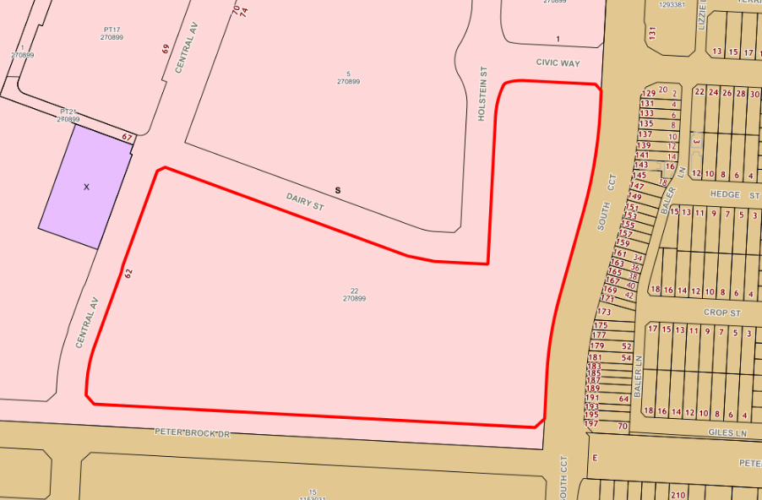  The maximum building height for this site is 24m (S) as shown on height of building map HOB_004. | In relation to the RL of a building, the vertical distance from existing ground level to the highest point of the building:  Commercial Building 3 = existing ground level RL 100.9, highest point of building RL 130.06 = 29.16m  Commercial Building 4 = existing ground level RL 100.70, highest point of building RL 130.060 = 29.36m | No. (Clause 4.6 written request submitted)
4.6 Exceptions to development standards  (4) Consent must not be granted for development that contravenes a development standard unless—  a) the consent authority is satisfied that—  - the applicant’s written request has adequately addressed the matters required to be demonstrated by subsection (3), and  - the proposed development will be in the public interest because it is consistent with the objectives of the particular standard and the objectives for development within the zone in which the development is proposed to be carried out, and  b) the concurrence of the Planning Secretary has been obtained. | The applicant has submitted a written request to contravene clause 4.3. Consideration of the written request is made in the main body of the assessment report. | Yes.
6.2 Public utility infrastructure  (1) Development consent must not be granted for development on land in an urban release area unless the Council is satisfied that any public utility infrastructure that is essential for the proposed development is available or that adequate arrangements have been made to make that infrastructure available when it is required. | Council staff are satisfied the site contains essential public utility infrastructure. | Yes.
6.3 Development in Special Area.  (2) The consent authority must not grant development consent for development on land in a special area unless a development control plan that provides for detailed development controls has been prepared for the land. | The site is identified under the former Growth SEPP as being special area ‘D’ – subject to consideration against section 5 and Part B1 of the Oran Park DCP. Part B1 of the Oran Park DCP provides detailed development controls that have been prepared for the land. The proposal has been assessed in detail against this part under a separate attached assessment table. | Yes.

